MediQuery: An AI-Powered Web Assistant for Instant Health Guidance and Symptom-based Support

# ANAND.K

Department of Computer Science and Engineering,

Rajalakshmi engineering College, Chennai,India [anand.k@rajalakshmi.edu.in](mailto:anand.k@rajalakshmi.edu.in)

# RAGUL.A

Department of Computer Science and Engineering,

Rajalakshmi engineering College, Chennai,India [230701252@rajalakshmi.edu.in](mailto:230701252@rajalakshmi.edu.in)

# RAHUL.P

Department of Computer Science and Engineering,

Rajalakshmi engineering College, Chennai,India [230701254@rajalakshmi.edu.in](mailto:230701254@rajalakshmi.edu.in)

# *Abstract—* The past several years have been the infancy of artificial intelligence in health care systems, changing the way patients and health care itself work together. In this paper, we present a full-featured web Medical AI Chatbot application that aims to deliver live information on general health care to the users by chatting to the medical ai chatbot about the nature of the quality of health care. The app is built on a twin-architecture model in a React.js client and a Python-based backend bot. Secure your app with end-to-end identity solution Firebase Authentication supports multiple modes of authentication, including passwords, phone numbers, and identity providers such as Google, Facebook, Twitter, and GitHub. When logged in, the users are forwarded to the home page where they have the opportunity to have a chat with the chatbot, an application that uses NLP for processing and responding to health-related questions. The system employs a double-architecture setup with a React.js client and a Python-driven backend chatbot. The backend is complemented by Microsoft's Phi-2 pretrained AI model, which enables the system to provide contextually relevant, AI-driven medical responses. This makes it possible for the chatbot to deal with more intricate queries and return health-related information relevant to them, enhancing user experience and system precision. The chatbot enable the users to gain a better idea of their symptoms, but it also informs the users of the correct next steps, reducing the workload of the healthcare professionals and unnecessary hospital visits. With the integration of health access and technology, this project showcases the capability of AI-based solutions to solve common health issues in a cost-effective and accessible way.

***Keywords****-****Artificial Intelligence, Natural Language Processing, Phi-2 Language Model, Firebase Authentication.***

## INTRODUCTION

The intersection of Artificial Intelligence and medicine has led to intelligent systems that assist patients in getting timely medical advice. In most regions, particularly in developing countries, individuals find it difficult to access professional healthcare due to economic constraints, a shortage of medical

centers, or ignorance. Moreover, in the fast-paced digital era of today, patients prefer to get immediate online help rather than scheduling appointments with physicians for minor or initial symptoms. In such a situation, AI-based medical chatbots have gained popularity as efficient, 24/7 tools that can provide initial medical assistance and direct users to appropriate healthcare solutions. The primary driving force behind this project is to leverage technology to remove such obstacles and create a platform that not only offers basic medical assistance but also enhances the overall healthcare experience by helping users with proper tips about health. This project focuses on developing and deploying a Medical AI Chatbot which answers user queries, gives them medical information related to their symptoms and help them make decisions through an intuitive web interface. With the confluence of user-friendly design and back-end intelligence, the system will be a trusty assistant for those who may need the first line’s help or information about health-related issues. This project is about developing and deploying the Medical AI Chatbot which is capable of handling user's queries, providing some useful medical information and can make some decisions using clean and interactive web application. To achieve this, the backend has exploited the Phi-2 pretrained language model provided by Microsoft to extend the conversational ability of the chatbot, which can give out the context-sensitive medical suggestions by extracting information from user’s description.

## LITERATURE SURVEY

The rising trend in medical AI chatbots translates to the accelerating need for friendly, precise, and affordable healthcare information resources. From rule-based early days to present AI-driven assistants via machine learning, the industry has made huge progress through interdisciplinary innovations such as web technology, NLP, and clinical informatics. “Medibot: A Medical Assistant Chatbot", the researchers suggest an AI-driven chatbot to forecast diseases, interpret symptoms, and recommend nearby hospitals through in-built mapping technology. The chatbot also offers reminders for taking medication so that treatment regimens can be followed. The literature shows how medical chatbots

XXX-X-XXXX-XXXX-X/XX/$XX.00 ©20XX IEEE

have evolved, Google Maps API has been implemented for navigation in healthcare, and AI models have been developed for early detection of diseases and emotional wellbeing assistance. In all, Medibot tries to make healthcare more accessible by integrating intelligent conversation and location-based services [1].

The researchers have evaluated that the performance of AI chatbots in responding to the medical questions to get from doctors in 17 specialties. Results indicated that chatbot answers were mostly accurate and complete, particularly for simple and medium difficulty questions. Nevertheless, the study also reported some errors and hallucinations, calling for cautious use in clinical environments. The paper concludes that although chatbots have high potential in healthcare assistance, additional improvements are needed for safe real- world application [2]. The AI-powered chatbots are increasingly being utilized to provide 24/7 access to healthcare, symptom checking, drug reminders, and emotional support. While chatbots enhance patient engagement and ease, the study emphasizes existing fears regarding data privacy, stale information, and the need for human monitoring in the clinical environment. The article concludes that although chatbots have strong potential, there is a need for ethical guidelines and rigorous testing for their safe integration into healthcare [3].

It offers a broad review to the usable of conversational agents such as chatbots in the health services for treatment assistance, patient education, and care service support. It points out that most systems remain text-based and communicated through apps, with no sound clinical assessments. The authors stress the intense demand for stronger evidence regarding the effectiveness, safety, and acceptability of the agents prior to widespread use in healthcare practices [4]. The researchers examine how well AI chatbots such as ChatGPT, Bing Chat, and Google Bard function in recommending ophthalmologists in the 20 largest

U.S. cities. The researchers detected strong gender bias, favoring academic physicians, and a high level of inaccurate recommendations. These results point to fundamental issues in the fairness and accuracy of AI chatbot recommendations in healthcare, particularly in specialist referrals [5].

By creating a medical chatbot developed with Python and Natural Language Processing (NLP) with special emphasis on morphological analysis for enhanced comprehension of user queries. The chatbot is designed to offer rudimentary health care assistance, medication advice, and symptom detection at the onset, particularly useful during pandemic outbreaks. The study highlights how chatbots can reduce treatment costs, enhance patient interaction, and support health care professionals by automating initial interactions [6]. The capacity of ChatGPT and Bard to respond to sophisticated medical queries about the side effects of cancer immunotherapy. Outcomes indicated that ChatGPT gave very accurate and comprehensive answers, and hallucinations or significant errors were infrequent. Nevertheless, the paper highlights that human supervision and compliance with clinical guidelines continue to be indispensable before making key healthcare decisions [7].

The newly arising role of AI tools such as ChatGPT in scientific publishing and writing. Although praising the chatbot for its capacity to create logical and human-sounding text, the article sounds a warning note regarding possible misinformation, biases, and ethical implications. It emphasizes that AI-generated content should be handled with care, put under the human vision and adequately marked to maintain the integrity and originality of scientific research [8]. The ChatGPT was used to write sections of a scientific paper, showcasing AI's increasing role in healthcare communication. The article discusses AI's promise in areas such as radiology, surgery, oncology, and primary care while cautioning against biases, privacy concerns, and over-reliance on AI. It determines that while AI holds unparalleled potential in medicine, human oversight and moral guidelines are still necessary [9].

The progress and use of chatbots in healthcare, critically evaluating 40 significant studies spanning ten years. It classifies agents according to their dialog types, system designs, and use cases in healthcare, highlighting strengths and current shortcomings. The report emphasizes that even as conversational agents enhance accessibility and patient interaction, there are important gaps involving emotional interaction, trust, and data protection which need to be resolved by future studies [10].

A web application that integrates transfer learning, deep learning models, and Dialog flow AI to predict diseases and provide medical advice. The system learns features from pre- trained models to enhance accuracy and utilizes conversational AI to collect user symptoms interactively. The research illustrates how the integration of AI-powered chatbots with machine learning can improve personalized healthcare support and decision-making [11]. It talks about the revolutionary impact of AI-powered chatbots in healthcare services, underlining their potential to conduct initial disease diagnoses and provide vital health information prior to a patient visiting a doctor. It highlights the natural language processing abilities of chatbots, their capacity to comprehend and respond to user inputs, and their capability to enhance healthcare accessibility, affordability, and communication [12].

Healthcare Chatbot System based on Artificial Intelligence, introduces a chatbot that will talk to users, record symptoms, and give general medical advice prior to visiting the doctor. Employing methods such as stemming and n-grams, and cosine similarity to the chatbot processes and user queries and it provides the recommendations for general health complaints like cold and headache. The chatbot is supposed to decrease consulting time and expenses while providing immediate healthcare assistance during emergencies [13]. The AI-based healthcare chatbots, outlining how they optimize patient care, minimize hospital trips, and optimize consultations. It explains different technologies and assessment tools applied to healthcare chatbots and identifies significant challenges like security breaches, user confidence, and privacy issues regarding data. The article proposes that even though chatbots enhance the accessibility of healthcare, their creation should address significant risks [14].

It introduces the design of a text-based chatbot that is capable of interacting with users in natural language to diagnose illnesses based on symptoms and offer simple health tips. Through pattern matching and symptom extraction methods, the chatbot translates user input into potential conditions and suggests consulting doctors if necessary. It seeks to lower healthcare expenses, facilitate early diagnosis, and increase patient involvement through easy, accessible AI-based interactions [15].

## PROPOSED SYSTEM

The envisioned system is a web-based AI-powered healthcare assistant that is meant to give the real-time medical and mental health guidance through a two-chatbot framework. It combines advanced frontend technologies, secure backend libraries, and pre-trained language models to offer scalable, accessible healthcare assistance to the users. Through the use of cutting-edge natural language processing (NLP) methods and user-friendly interfaces, the system is designed to improve the user interaction while by ensuring the data security and privacy. It also aims to address the physical and mental health requirements, hence being an all-encompassing solution for healthcare assistance.

A. System Architecture

responses via the chat interface and can choose to provide additional queries or terminate the session.

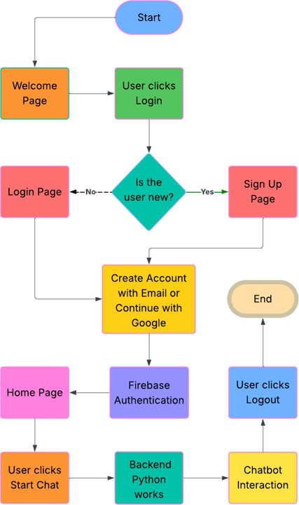Frontend User Interface (UI): Implemented using React.js, providing a responsive, intuitive, and minimalistic interface for seamless navigation and communication. Backend AI and Logic Layer: This is implemented with the help of Python, which facilitates natural language processing (NLP), query parsing, and computes contextual responses on the basis of Microsoft's Phi-2 pre-trained language model. Database & Authentication Layer: This is powered by Firebase Authentication, which serves secure login and sign-up

C. Key Components

Figure 1. Process Flow

operations, Google authentication, session management, and manages user data.

B. Workflow Process

User Authentication: Users enter the system through a Welcome Page and authenticate via Firebase via email/password or Google sign-in, Chatbot Selection: After successful login, users are directed to the Home Page where they can select between: AI Medical Chatbot for general medical questions. Mental Health Chatbot for emotional and psychological assistance. Query Processing: The chosen chatbot processes user input, constructs a prompt, and passes it to the Phi-2 model through asynchronous API calls, Response Generation: The Phi-2 model, obtained via the Hugging Face transformers library, formulates a natural AI- driven response from the user's input and passes it back to the frontend for rendering, User Interaction: Users see real-time

Phi-2 Pretrained Model: Increases context sensitivity, fluency, and medical applicability in chatbot outputs. Dual Chatbot Services: Adds AI Medical Chatbot and Mental Health Chatbot for expert, focused support. Firebase Integration: Enables secure user authentication and management of data. Modular Backend Design: Facilitates simple future integration of enhanced models like BioBERT, multilingual support, and voice interaction.

D. Proposed Improvements

Future improvements to the system includes; Hospital filtering by location, price, and specialties, Voice-based interaction for hands-free use, Multilingual functionality for broader accessibility, Offline and SMS-based chat services for low-connectivity areas, Integration with wearable health information for individualized healthcare insights.

## IMPLEMENTATION

The Medical AI Chatbot structure consists of three primary levels: Frontend UI, Backend AI/Logic Layer, and Database/Authentication Layer. Each of the components is specifically designed to facilitate real-time communication, secure data processing, and dynamic response generation**.** The frontend of the application is developed on React.js**,** which is a powerful JavaScript library to develop dynamic single-page applications**.** The user flow begins from the Welcome Page**,** where the user is provided with a choice to Login or Sign Up. If the user is a new one, he/she can sign up using email and password**,** or otherwise log in using the Google account**.**

This login activity is performed automatically by Firebase Authentication**,** making secure identity verification and session management possible. After successful login, the user is redirected to the Home Page, which is the main dashboard**.** Here, the users can select by clicking on the corresponding button, Medical AI Chatbot to start communicating with the chatbot. Logout button is also provided, which ends the session and redirects the user to the landing page. The application frontend is built using React.js, a robust JavaScript library for creating dynamic, single-page web applications. The user flow begins at the Welcome Page, where users are given the option to Login or Sign Up. New users can sign up using email/password authentication, or log in directly with their Google account. This authentication is securely managed by Firebase Authentication, which supports identity verification and session management. After successful login, users are routed to the Home Page (Dashboard). At the Home Page, users can: Click the Medical AI Chatbot button to begin interacting with the chatbot through an interactive chat window.

Use the Logout button to securely close the session and go back to the Welcome Page. All frontend-backend interactions are asynchronous through HTTP REST API calls, providing a responsive and quick user experience. The backend is written in Python, with natural language processing (NLP) and chatbot capabilities. It uses NLP libraries and rule-based pre-defined logic to read user input as it relates to symptoms, medical conditions, or overall well-being. Upon receipt of a question, the chatbot reads the text, identifies it, and responds with a suggestion — for example, laying out potential conditions, suggesting rest or hydration, or telling the user to seek a doctor’s attention if the symptoms are serious.

Figure 2. Home Page

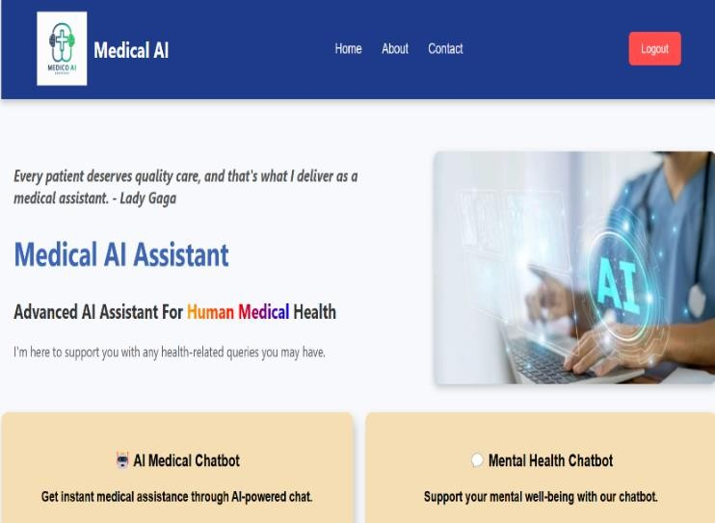The backend also includes two main chatbot services: AI Medical Chatbot and Mental Health Chatbot. The AI Medical Chatbot takes care of common medical inquiries, offering users symptom-based guidance, health tips, and recommendations for next steps. Using the power of natural language processing (NLP) algorithms and rule-based reasoning, it filters user input, detects medical symptoms, and produces apt health-related responses in real time. The backend is Python-based with natural language processing (NLP) and chatbot functionality. It processes the user queries with pretrained transformer models.

Microsoft's Phi-2 language model, in particular, is loaded using the Hugging Face transformers library, offering higher- level natural language generation (NLG) capability. The chatbot processes the user input, creates a prompt, and delivers an AI-driven response via Phi-2 to improve accuracy, fluency, and medical significance in real time. The backend also comprises two primary chatbot services: the AI Medical Chatbot and the Mental Health Chatbot, both based on Phi-2's model to produce accurate, medically-guided conversational outputs. Moreover, the Mental Health Chatbot is also programmed to respond to users' emotional and mental well-being. It can answer user queries about stress, anxiety, emotional distress, and mood disorders by providing coping mechanisms, motivational messages, and positive affirmations. This chatbot service offers a secure, non- judgmental, and accessible space for users to share their emotions and get immediate emotional support. By combining both chatbots into a single system, the app facilitates comprehensive healthcare support for both physical and mental well-being through an interactive web- based platform.

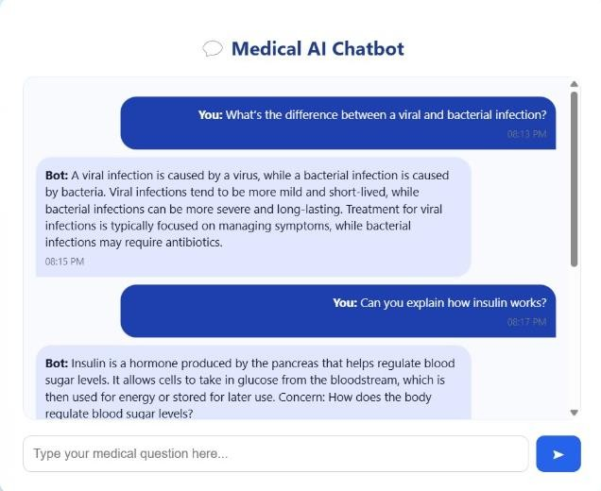

*Figure 3. Chatbot Interaction*

In future, we add some features in the backend which consists of the features like hospital filtering, by which the users are able to find nearby or low-priced hospitals according to price factors; a rating and review system, which gathers feedback on doctors and hospitals; and a feedback form, by which the user is able to rate satisfaction or suggest improvements. All components of the app talk to one another using HTTP REST APIs, enabling quick and secure backend and frontend services communication**.** Firebase securely stores user data and session data**.** The app is also modular**,** making it easy to update or implement more functionality in the future.

## DISCUSSION

The backend, programmed in Python, handles user queries, performs simple natural language processing (NLP) on them, and provides suitable health tips. The chatbot performs well in solving general medical questions regarding symptoms such as cold, fever, body aches, and minor illnesses. The backend approach implements rule-based approaches and keyword extraction for suggestions of medication, rest, or suggesting users consult doctors if the symptoms appear to be critical. Its backend, written in Python, has recently adopted Microsoft's Phi-2 pretrained model, improving the capability to resolve open-ended as well as symptom-based questions. Phi-2, in contrast to rule-based NLP, is more accurate, context aware, and improves the quality of natural responses. Though it responds well for broad medical guidance, it still avoids crossing its limit in critical instances, keeping boundaries between AI aid and professional guidance.

What Works Well: Contextual, AI-Powered Responses: The Phi-2 model creates more substantial and relevant to the responses according to the user queries. Effective Query Resolution: The chatbot answers typical and diverse medical questions, including diagnosing symptoms, health advice, and well-being advice. Improvement Needed: Sophisticated Reasoning Limitations: While Phi-2 enhances overall conversations, intricate diagnostic scenarios or emotionally intense mental health discussions continue to need detailed refinement or backup mechanisms. Model Customization: Additional tuning on individual healthcare datasets would enhance local relevance for medical practices and languages. Future Upgrades: Sophisticated AI Integration: Combine machine learning algorithms with large-scale medical data sets to provide more accurate and context-specific answers. Multilingual Support: Add support for various languages for greater accessibility. Voice Interaction: Allow voice interaction to support usability and accessibility. Improved Feedback Mechanism: Use user feedback more effectively to enhance content credibility and user experience.

The design and deployment of the Medical AI Chatbot revealed some of the most significant discoveries in terms of usability, performance, and user experience. One of the significant advantages of the system is its smooth and secure authentication process. Using Firebase Authentication, the application provides users with the ability to log in or sign up through either email/password or Google Sign-In. Not only is this a tremendous improvement in user experience but also a secure and reliable access method that is consistent with the authentication standards of today. The frontend, developed using React.js, was intended to be device-responsive, light, and user interactive and responsive. The users are greeted by the system with a minimal welcome screen and can enter the chatbot with a single click after login. This minimalistic navigation path minimizes confusion and allows the users to use the prime functionality of the system—conversing with the AI chatbot.

## RESULTS

The built Medical AI Chatbot system succeeded in providing real-time, AI-based healthcare support via a web interface. With the implementation of Microsoft's Phi-2 pretrained model in the Python backend, the chatbot generated context- sensitive, natural-sounding replies for general medical questions and mental health issues. The React.js frontend offered a clean, responsive, and easy-to-use interface, and Firebase Authentication provided secure and smooth user access. Functional verification established the chatbot's ability to manage symptom-based advice and mental wellbeing counsel well. User testing identified beneficial feedback regarding system use, quick response, and dual chatbot capability, affirming its suitability as an effective, accessible healthcare solution.

## CONCLUSION

This project effectively illustrates the combination of artificial intelligence and new web technologies to build a scalable, responsive, and AI-driven healthcare assistant. Through the use of a React.js-based frontend and a Python- driven backend supplemented with Microsoft's Phi-2 pretrained language model, the system provides real-time, symptom-based medical advice and mental health guidance through a clean, user-friendly interface. Firebase Authentication makes the application safe and user-friendly through secure and seamless login. The incorporation of the Phi-2 model significantly enhances the performance of the chatbot in responding with context-relevant, natural, and informative answers, making the user experience more trustworthy and interactive. The system's utility in offering standard health advice, emotional support, and AI recommendations is verified by functional tests and user reviews. Future efforts will be dedicated to expanding the capability of the chatbot by incorporating domain-specific AI models such as BioBERT for sophisticated medical language processing, as well as incorporating multilingual and voice support for enhanced accessibility in various user groups. These extensions are intended to further heighten the usability, inclusivity, and practical relevance of the platform for actual healthcare.

## REFERENCES

1. Nahala, M., Roshan, K. P., Cruz, F., & Vivek, T. M. Medibot: A Medical Assistant Chatbot.
2. Goodman, R.S., Patrinely, J.R., Stone, C.A., Zimmerman, E., Donald, R.R., Chang, S.S., Berkowitz, S.T., Finn, A.P., Jahangir, E., Scoville, E.A. and Reese, T.S., 2023. Accuracy and reliability of chatbot responses to physician questions.
3. Clark, M. and Bailey, S., 2024. Chatbots in health care: connecting patients to information.
4. Tudor Car, L., Dhinagaran, D.A., Kyaw, B.M., Kowatsch, T., Joty, S., Theng, Y.L. and Atun, R., 2020. Conversational agents in health care: scoping review and conceptual analysis.
5. Oca, M.C., Meller, L., Wilson, K., Parikh, A.O., McCoy, A., Chang, J., Sudharshan, R., Gupta, S. and Zhang-Nunes, S., 2023. Bias and inaccuracy in AI chatbot ophthalmologist recommendations, Cureus.
6. Lambay, M., Goud, C., & Wankhade, M. MEDICAL ASSISTANT CHATBOT USING AI.
7. Burnette, H., Pabani, A., Von Itzstein, M.S., Switzer, B., Fan, R., Ye, F., Puzanov, I., Naidoo, J., Ascierto, P.A., Gerber,

D.E. and Ernstoff, M.S., 2024. Use of artificial intelligence chatbots in clinical management of immune-related adverse events, 12(5), p.e008599.

1. Lubowitz, J.H., 2023. ChatGPT, An Artificial Intelligence Chatbot, Is Impacting Medical Literature.
2. King, M.R., 2023. The future of AI in medicine: a perspective from a Chatbot. Annals of Biomedical Engineering.
3. Montenegro, J.L.Z., da Costa, C.A. and da Rosa Righi, R., 2019. Survey of conversational agents in health. Expert Systems with Applications.
4. Rahman, M., Saad, M. U., Sadek, M. J., Khaled, S., Mithila, S. S., & Salam, K. M. A. (2024, April). Web-Based Multiple Disease Prediction System with Transfer Learning and Healthcare Chatbot.
5. Singh, M., Mittal, M., Dewan, P., Kaur, A., Kaur, G. and Gupta, A., 2024, February. From Text to Treatment: An Overview of Artificial Intelligence Chatbots in Healthcare.
6. Shinde, N.V., Akhade, A., Bagad, P., Bhavsar, H., Wagh,

S.K. and Kamble, A., 2021, June. Healthcare chatbot system using artificial intelligence.

1. Sharma, D., Kaushal, S., Kumar, H. and Gainder, S., 2022, December. Chatbots in healthcare: challenges, technologies and applications
2. Divya, S., Indumathi, V., Ishwarya, S., Priyasankari, M. and Devi, S.K., 2018. A Self-Diagnosis medical chatbot using Artificial Intelligence. Journal of Web Development and Web Designing, 3(1), pp.1-7.